**The Day of Pentecost**

**Listen on your radio at FM 105.9**

**May 31, 2020**

**10:30 AM**

**Zion Lutheran Church, Priddy TX**

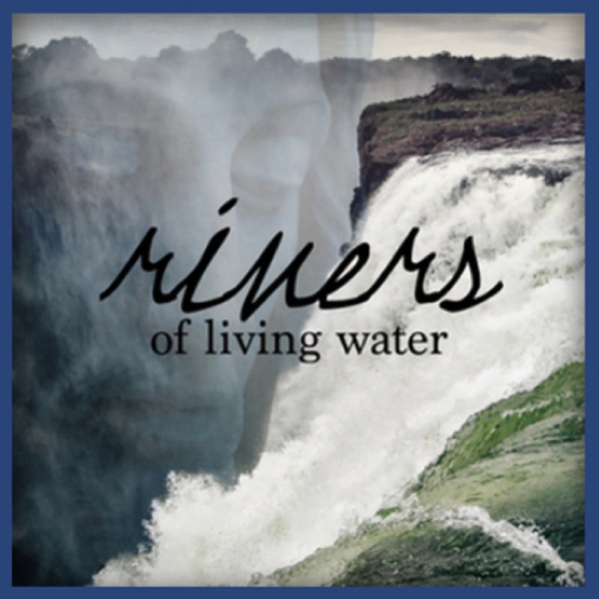**Pastor Mark Schimmel**

+ GATHERING +

God calls, gathers, and enlightens believers through the Holy Spirit, and in this worship service we hear the Word of God and respond as His people in prayer and praise. We begin our service sharing the news of the congregation and then join in reflection to prepare for worship. The invocation calls God to be present with us. In the Kyrie, we greet our Lord and ask for his mercy and then join in a hymn of praise and thanksgiving. Finally, we offer a prayer of the day to mark the time of the year and other special concerns of the church.

**Greeting & Announcements**

**Invocation and Confession**

The sign of the cross may be made by all in remembrance of their Baptism.

P: In the name of the Father, and of the + Son, and of the Holy Spirit.

C: **Amen**

P: Almighty God, to whom all hearts are open, all desires known, and from whom no secrets are hid: Cleanse the thoughts of our hearts by the inspiration of your Holy Spirit, that we may perfectly love you and worthily magnify your holy name, through Jesus Christ our Lord.

C: **Amen**

P: If we say we have no sin, we deceive ourselves, and the truth is not in us. But if we confess our sins, God who is faithful and just will forgive our sins and cleanse us from all unrighteousness.

Silence for reflection and self-examination.

P: Most merciful God,

C: **we confess that we are in bondage to sin and cannot free ourselves. We have sinned against you in thought, word, and deed, by what we have done and by what we have left undone.**

**We have not loved you with our whole heart;**

**we have not loved our neighbors as ourselves.**

**For the sake of your Son, Jesus Christ, have mercy on us.**

**Forgive us, renew us, and lead us, so that we may delight in your will and walk in your ways, to the glory of your holy name. Amen**

P: Almighty God, in his mercy, has given his Son to die for us and, for his sake, forgives us all our sins. As a called and ordained minister of the Church of Christ, and by his authority, I therefore declare to you the entire forgiveness of all your sins, in the name of the Father, and of the + Son, and of the Holy Spirit.

C: **Amen**

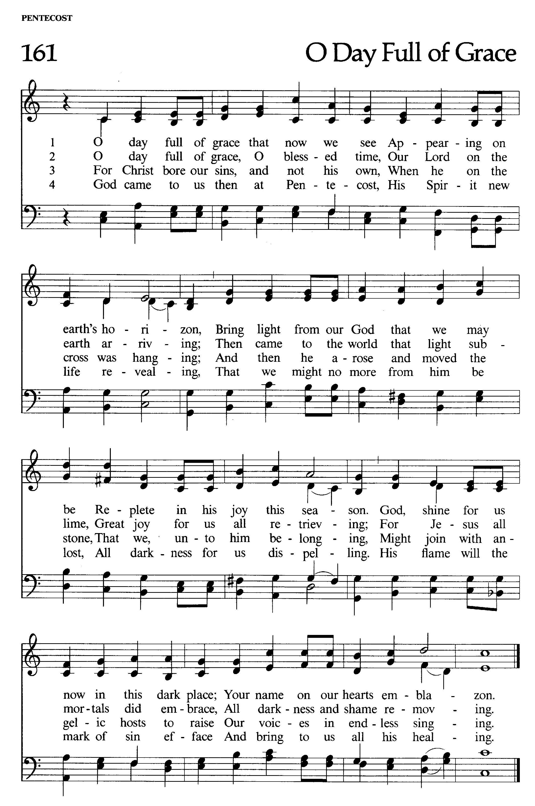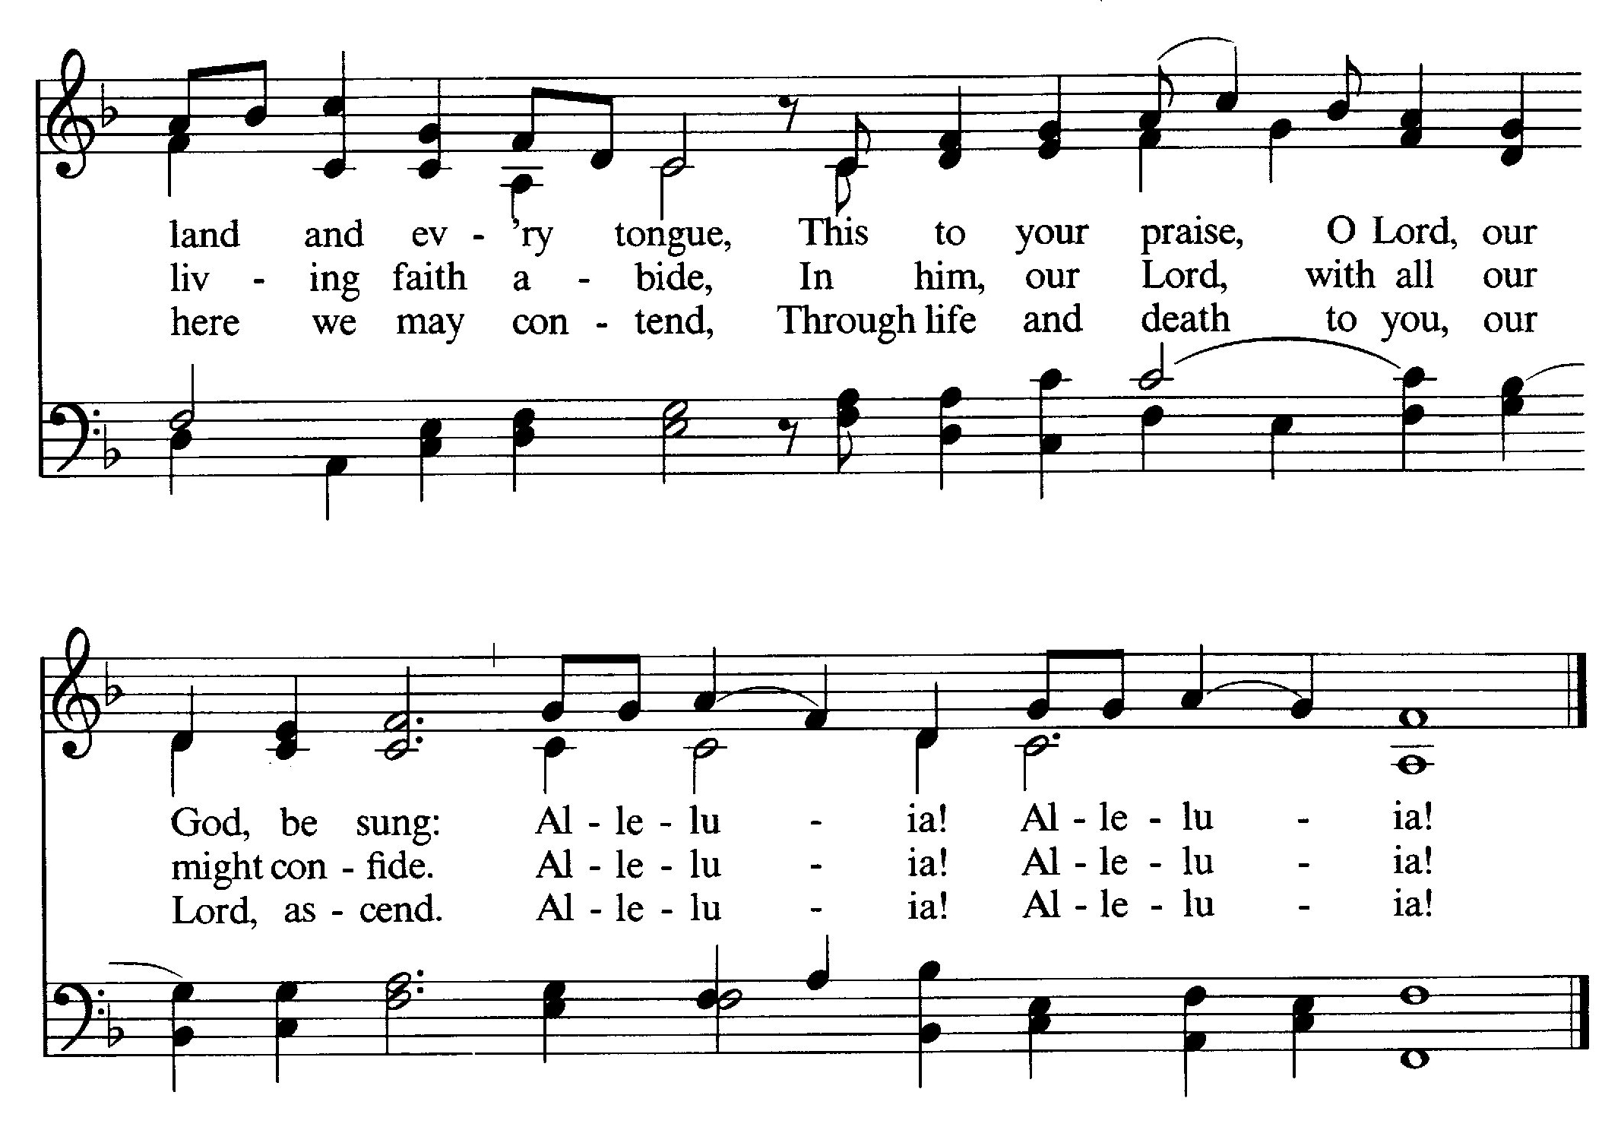

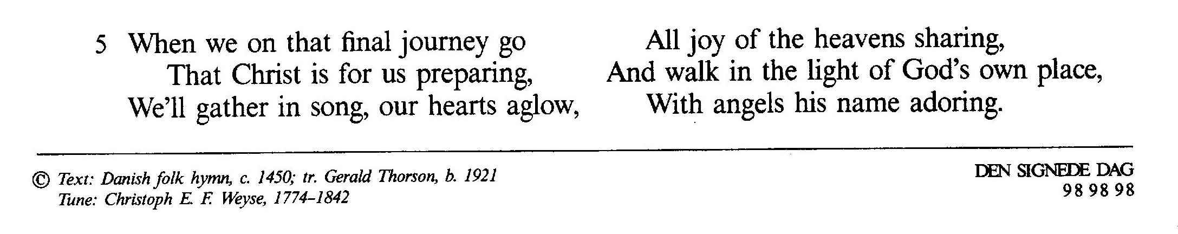P: The grace of our Lord Jesus Christ, the love of God, and the communion of the Holy Spirit be with you all.

**C: And also with you.**

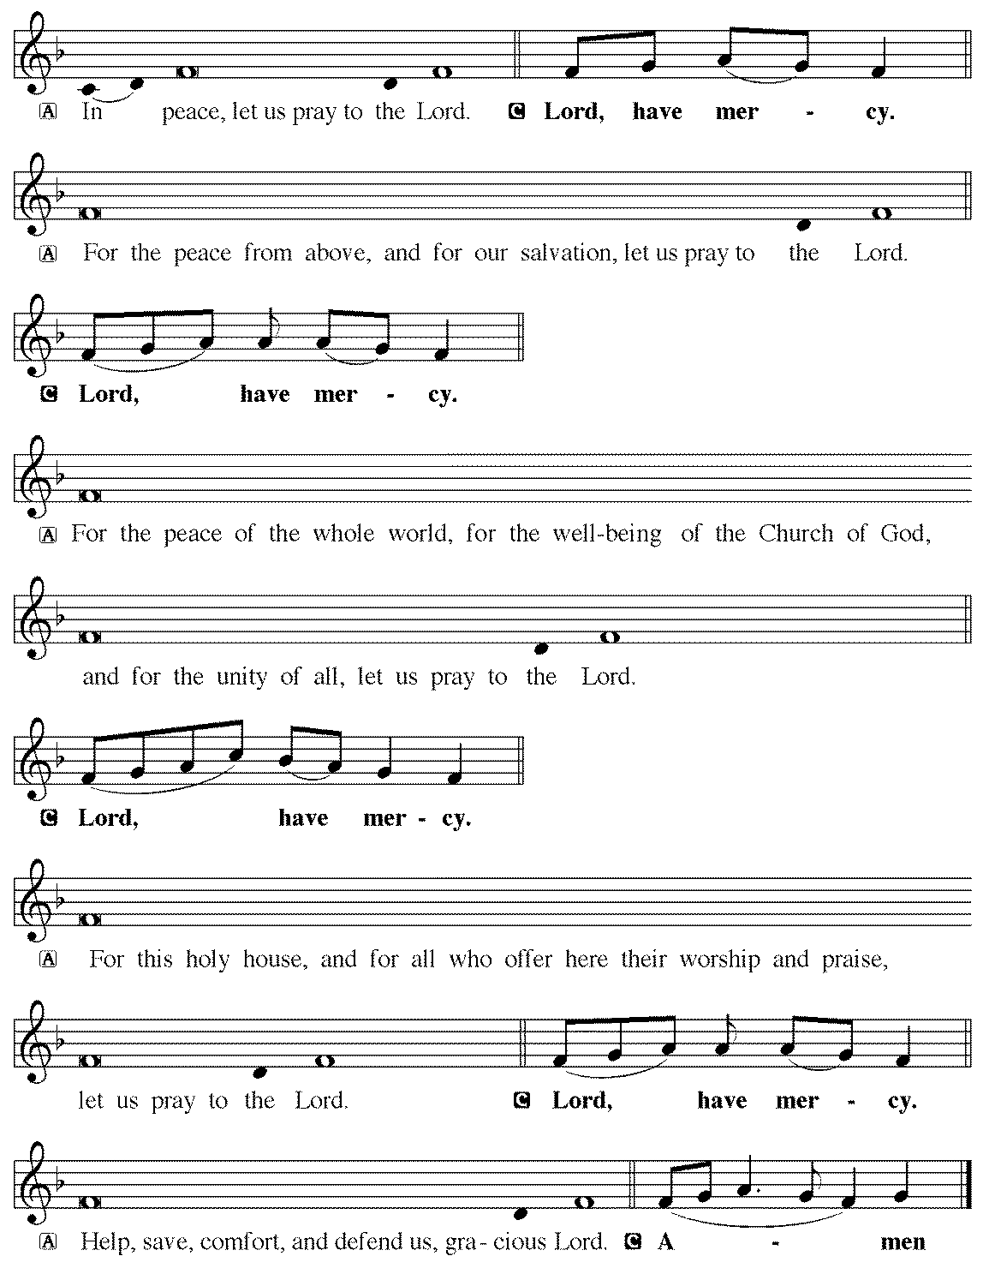

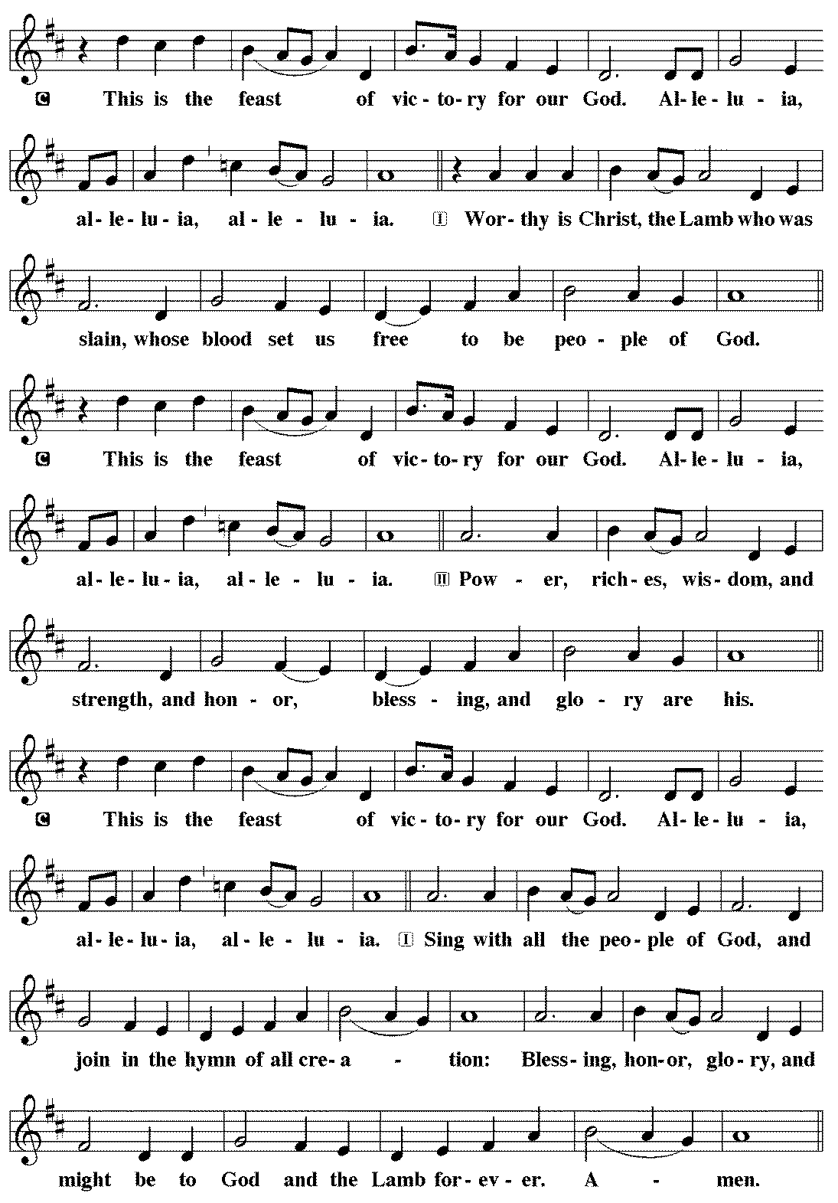

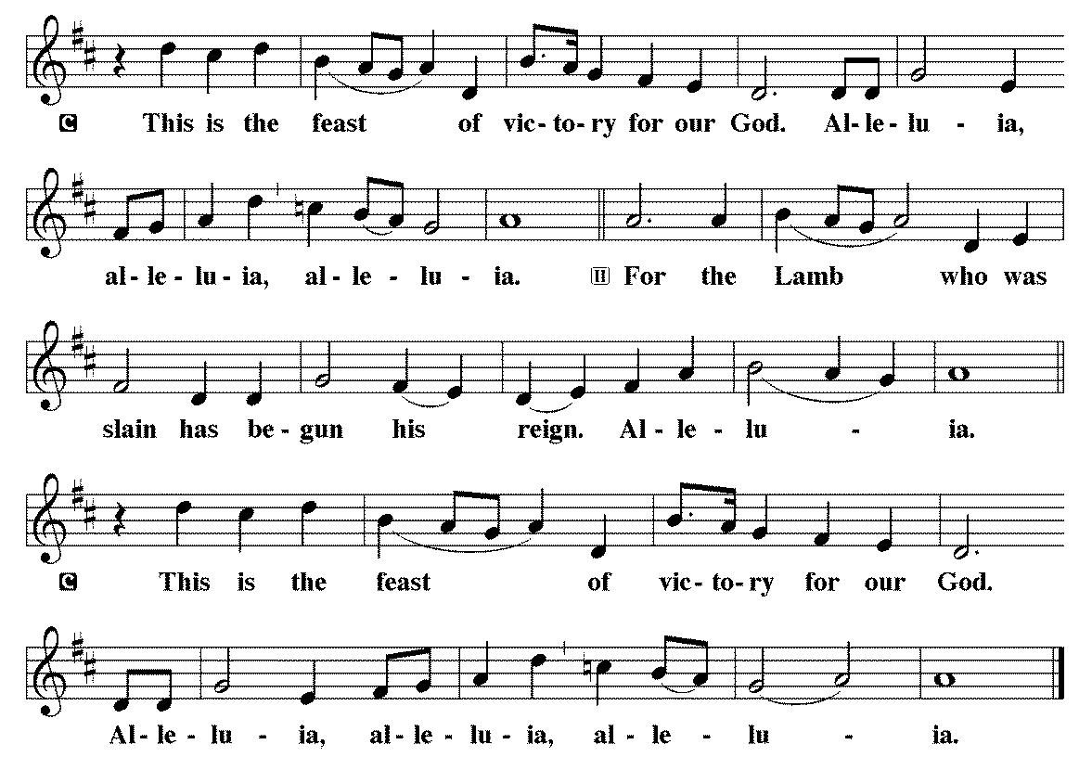**Salutation**

P The Lord be with you.

C And also with you.

**Prayer of the Day**

P O God, all good things can come from you alone; generously consider then our humble prayers. Inspire us to consider what is true, and direct us to accomplish what is right; through Jesus Christ, your Son, our Lord. He lives and reigns with you and the Holy Spirit, one God, now and forever.

C Amen.

**Numbers 11:24-30**

24Moses went out and told the people the words of the Lord. And he gathered seventy men of the elders of the people and placed them around the tent. 25Then the Lord came down in the cloud and spoke to him, and took some of the Spirit that was on him and put it on the seventy elders. And as soon as the Spirit rested on them, they prophesied. But they did not continue doing it. 26Now two men remained in the camp, one named Eldad, and the other named Medad, and the Spirit rested on them. They were among those registered, but they had not gone out to the tent, and so they prophesied in the camp. 27And a young man ran and told Moses, “Eldad and Medad are prophesying in the camp.” 28And Joshua the son of Nun, the assistant of Moses from his youth, said, “My lord Moses, stop them.” 29But Moses said to him, “Are you jealous for my sake? Would that all the Lord’s people were prophets, that the Lord would put his Spirit on them!” 30And Moses and the elders of Israel returned to the camp.

L This is the Word of the Lord.

C Thanks be to God.

**Psalm 25:1-15**

1To you, O Lord, I lift up my soul; my God, I put my trust in you; let me not be humiliated, nor let my enemies triumph over me.

**2Let none who look to you be put to shame; let the treacherous be disappointed in their schemes.**

3Show me your ways, O Lord, and teach me your paths.

**4Lead me in your truth and teach me, for you are the God of my salvation; in you have I trusted all the day long.**

5Remember, O Lord, your compassion and love, for they are from everlasting.

**6Remember not the sins of my youth and my transgressions; remember me according to your love and for the sake of your goodness, O Lord.**

7Gracious and upright is the Lord; therefore he teaches sinners in his way.

**8He guides the humble in doing right and teaches his way to the lowly.**

9All the paths of the Lord are love and faithfulness to those who keep his covenant and his testimonies.

**10For your name’s sake, O Lord, forgive my sin, for it is great.**

11Who are they who fear the Lord? He will teach them the way that they should choose.

**12They shall dwell in prosperity, and their offspring shall inherit the land.**

13The Lord is a friend to those who fear him and will show them his covenant.

**14My eyes are ever looking to the Lord, for he shall pluck my feet out of the net.**

15Turn to me and have pity on me, for I am left alone and in misery.

**Acts 2:1-21**

1When the day of Pentecost arrived, {the disciples} were all together in one place. 2And suddenly there came from heaven a sound like a mighty rushing wind, and it filled the entire house where they were sitting. 3And divided tongues as of fire appeared to them and rested on each one of them. 4And they were all filled with the Holy Spirit and began to speak in other tongues as the Spirit gave them utterance. 5Now there were dwelling in Jerusalem Jews, devout men from every nation under heaven. 6And at this sound the multitude came together, and they were bewildered, because each one was hearing them speak in his own language. 7And they were amazed and astonished, saying, “Are not all these who are speaking Galileans? 8And how is it that we hear, each of us in his own native language? 9Parthians and Medes and Elamites and residents of Mesopotamia, Judea and Cappadocia, Pontus and Asia, 10Phrygia and Pamphylia, Egypt and the parts of Libya belonging to Cyrene, and visitors from Rome, 11both Jews and proselytes, Cretans and Arabians — we hear them telling in our own tongues the mighty works of God.” 12And all were amazed and perplexed, saying to one another, “What does this mean?” 13But others mocking said, “They are filled with new wine.” 14But Peter, standing with the eleven, lifted up his voice and addressed them: “Men of Judea and all who dwell in Jerusalem, let this be known to you, and give ear to my words. 15For these people are not drunk, as you suppose, since it is only the third hour of the day. 16But this is what was uttered through the prophet Joel: 17‘And in the last days it shall be, God declares, that I will pour out my Spirit on all flesh, and your sons and your daughters shall prophesy, and your young men shall see visions, and your old men shall dream dreams; 18even on my male servants and female servants in those days I will pour out my Spirit, and they shall prophesy. 19And I will show wonders in the heavens above and signs on the earth below, blood, and fire, and vapor of smoke; 20the sun shall be turned to darkness and the moon to blood, before the day of the Lord comes, the great and magnificent day. 21And it shall come to pass that everyone who calls upon the name of the Lord shall be saved.’”

L This is the Word of the Lord.

C Thanks be to God.

**John 7:37-39**

37On the last day of the feast, the great day, Jesus stood up and cried out, “If anyone thirsts, let him come to me and drink. 38Whoever believes in me, as the Scripture has said, ‘Out of his heart will flow rivers of living water.’” 39Now this he said about the Spirit, whom those who believed in him were to receive, for as yet the Spirit had not been given, because Jesus was not yet glorified.

**Children’s Message & Sermon**

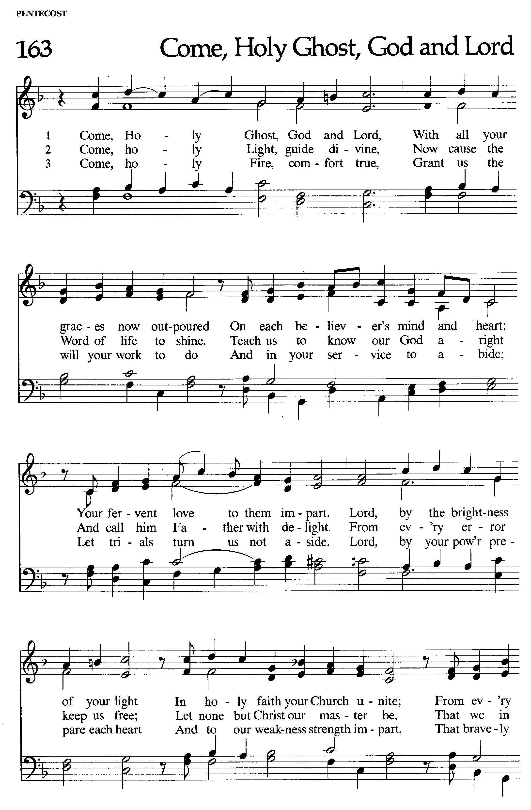

**The Apostles’ Creed**

I believe in God, the Father almighty, creator of heaven and earth.

I believe in Jesus Christ, his only Son, our Lord. He was conceived by the power of the Holy Spirit and born of the virgin Mary. He suffered under Pontius Pilate, was crucified, died, and was buried. He descended into hell. On the third day he rose again. He ascended into heaven, and is seated at the right hand of the Father. He will come again to judge the living and the dead.

I believe in the Holy Spirit, the holy catholic Church, the communion of saints, the forgiveness of sins, the resurrection of the body, and the life everlasting. Amen

**Prayer of the Church**

P: let us pray to the Lord:

**C: Lord, have mercy.**

+ SACRAMENT +

**The Exhortation**

As we describe in the Exhortation - as a church of the Lutheran Confessions - we believe, teach, and confess, that Christ is truly present in, with, and under the elements of bread and wine. All the baptized who understand they are sinners in need of forgiveness and who believe, as Christ’s words clearly state, “This is my body”, “this is my blood”, and understand that Christ offered himself as a sacrifice for sin once for all – as his words say; “for you, for the forgiveness of sin” - are welcome to the Lord’s Table. Those who have not yet received instruction are welcome to come for a blessing.

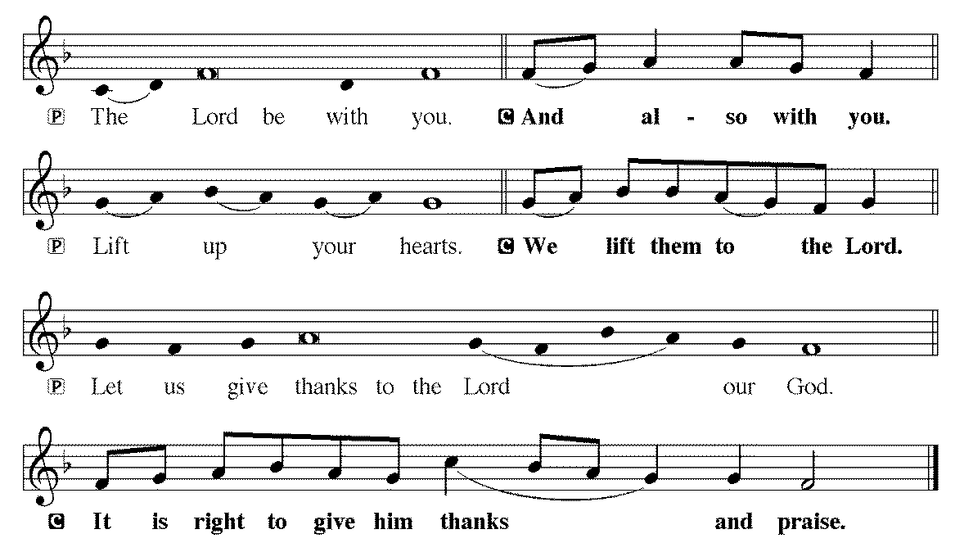

P: It is indeed right and salutary ...

… we praise your name and join their unending hymn:

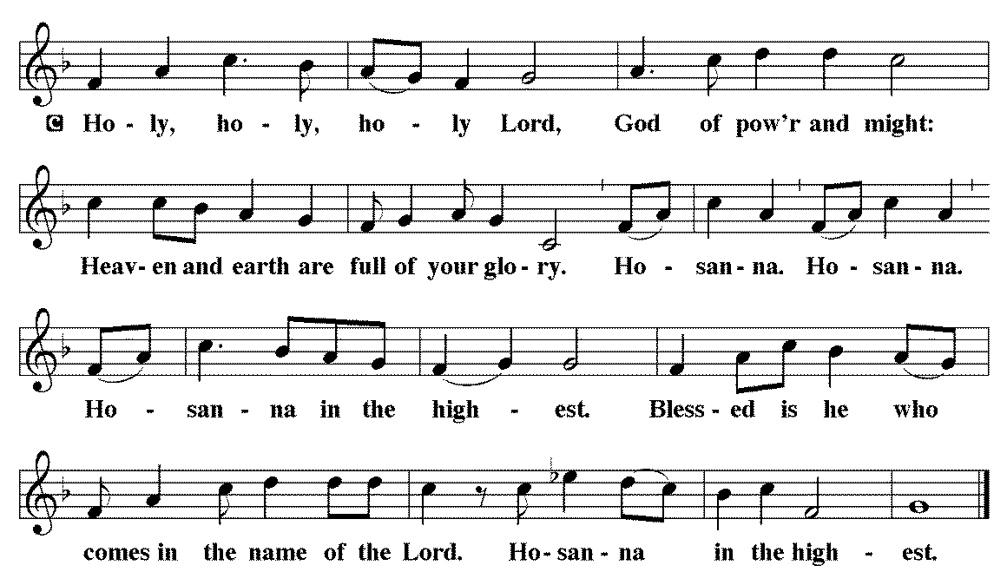

**The Words of Institution**

**The Lord's Prayer**

Our Father, who art in heaven, hallowed be thy name,

thy kingdom come, thy will be done, on earth as it is in heaven.

Give us this day our daily bread; and forgive us our trespasses, as we forgive those who trespass against us; and lead us not into temptation, but deliver us from evil.

For thine is the kingdom, and the power, and the glory, forever and ever. Amen

*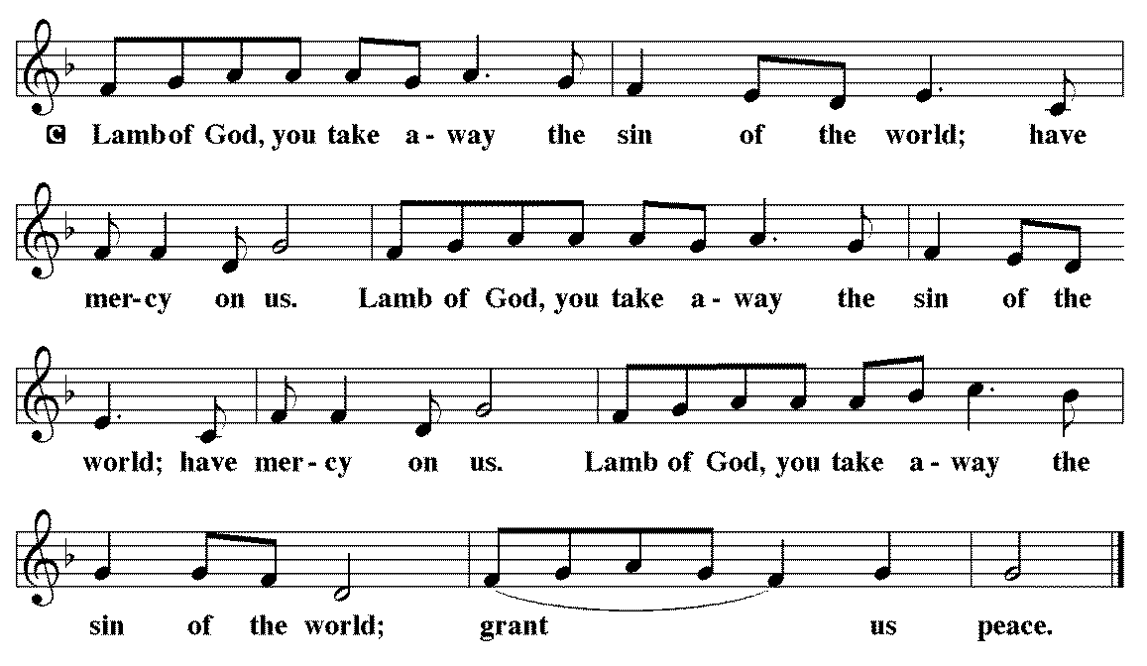***Agnus Dei (Lamb of God)**

**Distribution of Communion**

**Post-Communion Canticle**

**Post-Communion Prayer**

P: We give you thanks, almighty God, that you have refreshed us through the healing power of this gift of life; and we pray that in your mercy you would strengthen us through this gift, in faith toward you and fervent love toward one another; for the sake of Jesus Christ our Lord.

**C: Amen**

**The Benediction**

P: The Lord bless you and keep you.

The Lord make his face shine on you and be gracious to you.

The Lord look upon you with favor and + give you peace.

**C: Amen**

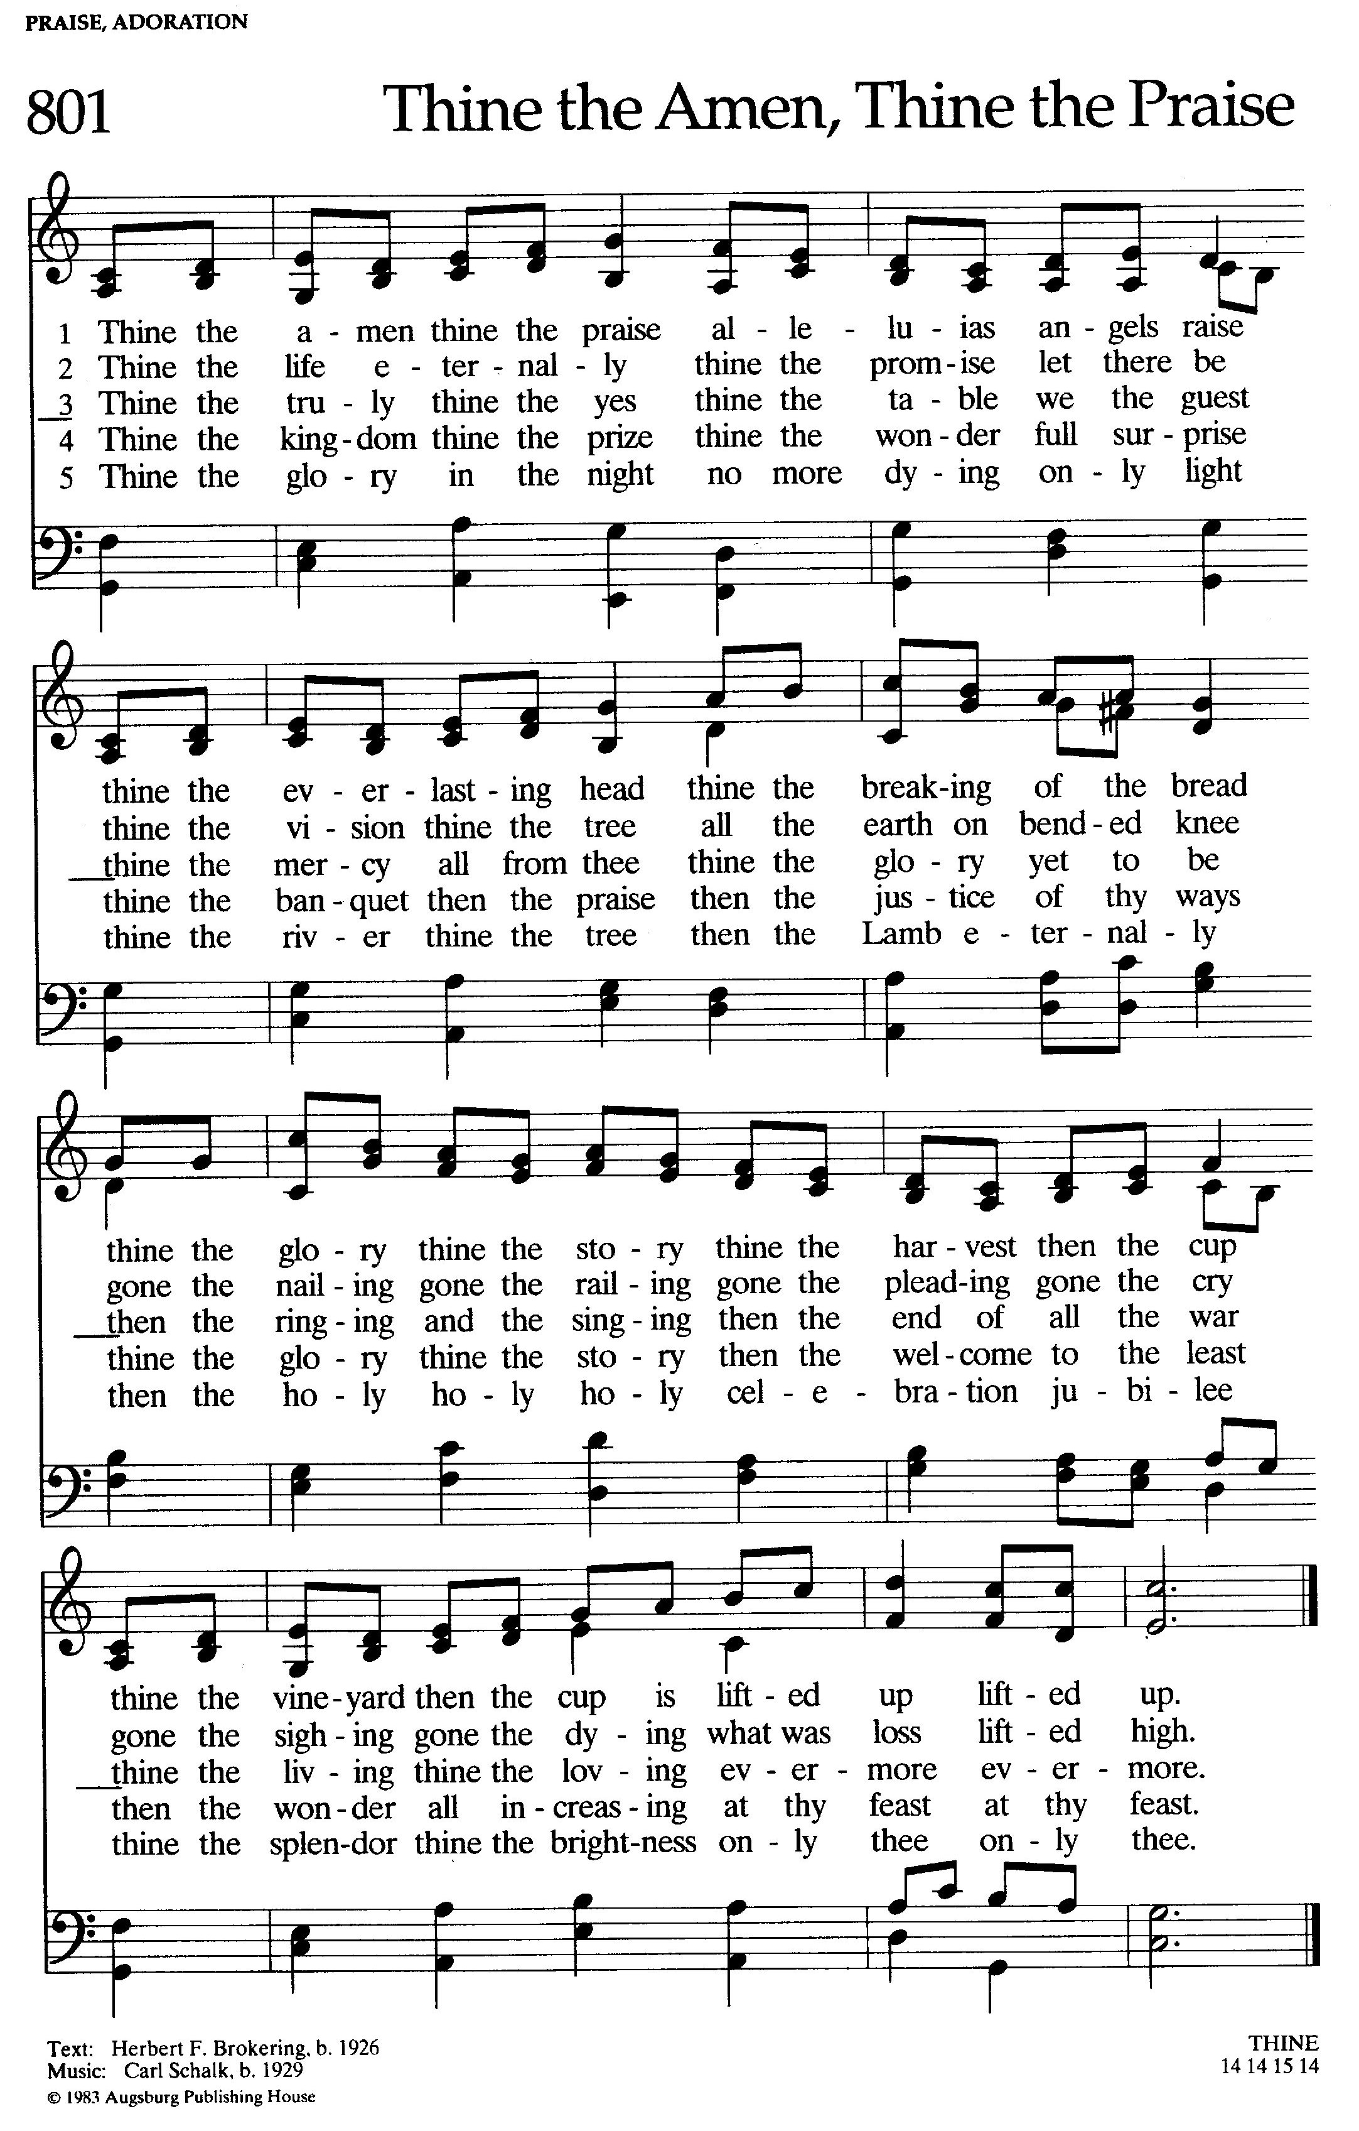

**Dismissal**

P: Go in Peace, serve the Lord!

**C: Thanks be to God!**

Offerings may be dropped in the plates by the exits on your way out.

Please take your bulletins with you as you go.